**Lesson Notes**

1. **What is the main purpose of an Operating System?**

* Have more efficient application programs (computer hardware, resource allocation)
* Consistent user experience (provides a standard user interface; windows and file explore)
* Allows multiple application to run at the same time

1. **What is the difference between Operating System Software and Use Application Software?**

* The difference between them is

1. **What is the difference between Operating System Software and Computer Hardware?**

* w

1. **What are the main parts of an Operating System?**

* Graphical user interface (GUI)
* System calls
* Device drivers
* I/O manager
* Memory manger
* Process manager
* Security monitor

1. **What are some popular operating systems?**

* Windows OS
* Mac OS
* Linux / Unix
* Android
* IOS

**Reference Diagram**

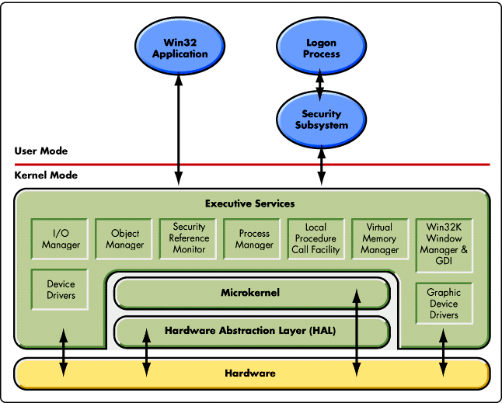

**Student Questions**

1. **What is a device driver?**
   1. **Provide a brief summary**
   * A software program that controls a certain type of hardware device.
   1. **List some devices that require a device driver.**
   * Some devices include printers, displays, CD-ROM readers, network or sound cards, computer mice or hard disks.
   1. **Provide a label on the reference diagram for the location of a device driver for your graphics card.**
   2. **Provide a label on the reference diagram for the location of a device driver for a locally attached printer.**
2. **What is a DLL?**
   1. **Provide a brief summary**
   * Dynamic-link library (DLL) is Microsoft's implementation of the shared library concept in the Microsoft Windows and OS/2 operating systems. These libraries usually have the file extension DLL, OCX (for libraries containing ActiveX controls), or DRV (for legacy system drivers). The file formats for DLLs are the same as for Windows EXE files – that is, Portable Executable (PE) for 32-bit and 64-bit Windows, and New Executable (NE) for 16-bit Windows. As with EXEs, DLLs can contain code, data, and resources, in any combination.
   1. **Explain how DLLs are related to user application programs**
   * Data files with the same file format as a DLL, but with different file extensions and possibly containing only resource sections, can be called resource DLLs. Examples of such DLLs include icon libraries, sometimes having the extension ICL, and font files, having the extensions FON and FOT.
   1. Provide a label on the reference diagram for the location of a DLL
3. **What is a windows manager?**
   1. **Provide a brief summary**
   * A window manager is system software that controls the placement and appearance of windows within a windowing system in a graphical user interface.
   1. **Explain how a windows manager is related to user application programs**
   * Most window managers are designed to help provide a desktop environment. They work in conjunction with the underlying graphical system that provides required functionality—support for graphics hardware, pointing devices, and a keyboard, and are often written and created using a widget toolkit.
   1. **Provide a label on the reference diagram for the location of a DLL**
4. **What is the windows task manager?**
   1. **Provide a brief summary**
   * The Windows Task Manager is a powerful tool packed with useful information, from your system’s overall resource usage to detailed statistics about each process.
   1. **List and explain four (4) types of system information provided by the task manager**
   * Users, Details, App history and Performance
   1. Provide a label on the reference diagram for the operating system components related to each type of information.